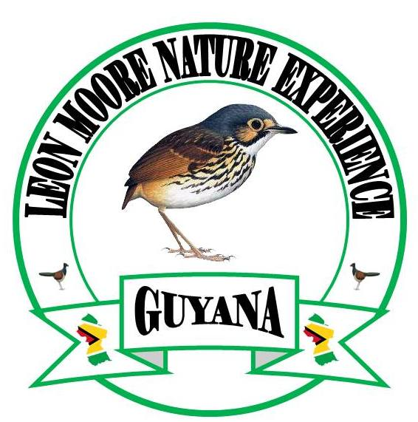

**Leon Moore Nature**

**Experience – Sun Parakeet Birding Tour**

Guyana is a small English-speaking country located on the Atlantic Coast of South America, east of Venezuela and west of Suriname. Deserving of its reputation as one of the top birding and wildlife destinations in South America, Guyana’s pristine habitats stretch from the protected shell beach and mangrove forest along the northern coast, across the vast untouched rainforest of the interior, to the wide open savannah of the Rupununi in the south. Guyana hosts more than 850 different species of birds covering over 70 families. Perhaps the biggest attraction is the 45+ Guianan Shield endemic species that are more easily seen here than any other country in South America.

These sought-after near-endemic species include everything from the ridiculous to the sublime - from the outrageous Capuchinbird with a bizarre voice unlike any other avian species to the unbelievably stunning Guianan Cock-of-the-Rock. While the majestic Harpy Eagle is on everyone’s “must-see” list, other species are not to be overlooked, such as Rufous-throated, White-plumed and Wing-barred Antbirds, Gray-winged Trumpeter, Rufous-winged Ground Cuckoo, Blood-colored Woodpecker, Rufous Crab-Hawk, Guianan Red-Cotinga, White-winged Potoo, Black Curassow, Sun Parakeet, Red Siskin, Rio-Branco Antbird, and the Dusky Purpletuft. These are just a few of the many spectacular birding highlights that can be seen in this amazing country.

Not only is Guyana a remarkable birding destination, but it also offers tourists the opportunity to observe many other unique fauna. The elusive Jaguar can sometimes be seen along trails and roadways. Several species of monkeys including Red Howler, Black Spider, Wedge-capped Capuchin, Brown Capuchin, Golden-handed Tamarin, Brown-bearded Saki and Squirrel Monkey are frequently seen in their natural habitats. As if that isn’t enough, you are nearly certain to see Capybara, Black Caiman (the largest member of the alligator family), Sloths, and Giant Otters. Other animals that are either less common or more elusive and therefore less likely but still possible to find are Tapir, Anaconda, Puma, and Giant Anteater. The largest fresh-water scaled fish in the world, the Arapaima, can be observed, along with an amazing diversity of reptiles and amphibians that will enhance your birding adventure.

**THE TOUR AT A GLANCE**

|  |  |  |
| --- | --- | --- |
| **Day 1** | **Nov 10th** | **Arrive in Georgetown** |
| **Day 2** | **Nov 11th** | **Georgetown and Surrounding** |
| **Day 3** | **Nov 12th** | **Georgetown to Iwokrama River Lodge** |
| **Day 4** | **Nov 13th** | **Iwokrama and Surround** |
| **Day 5** | **Nov 14th** | **Iwokrama to Atta Rainforest Lodge** |
| **Day 6** | **Nov 15th** | **Atta Rainforest Lodge and Surrounding** |
| **Day 7** | **Nov 16th** | **Atta Rainforest Lodge to Surama Lodge** |
| **Day 8** | **Nov 17th** | **Surama Lodge and Surrounding** |
| **Day 9** | Nov 18th | **Surama Lodge to Caiman house** |
| **Day 10** | **Nov 19th** | **Caiman House and Surrounding** |
| **Day 11** | **Nov 20th** | **Caiman House to Karasabai and Manari Ranch** |
| **Day 12** | **Nov 21st** | **Red Siskin Adventure and Lunch at Dadanawa** |
| **Day 13** | **Nov 22nd** | **Manari Ranch Surrounding & Schedule flight to Georgetown** |
| **Day 14** | **Nov 23rd** | **Final Departure** |

**Day 1, Nov, 10th .Arrive in Guyana:** Our tour will begin from the Cheddi Jagan International Airport. Since the tour is starting today, if you can plan your flight to land in Guyana the evening before so as to take advantage of day one early, that would be great.

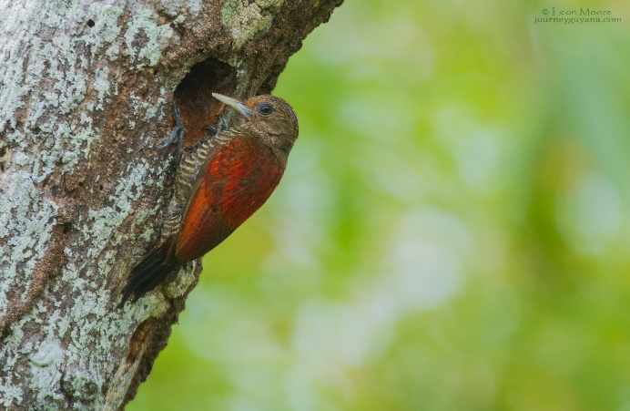If for some reason you can’t arrive a day early then you can arrive early on the morning of day one and the afternoon will be used to visit the Georgetown Botanical Gardens as this would be a great introduction to the birds of Guyana. Please advise if you intend arriving the previous day. After arriving in the vibrant city of Georgetown we will transfer to our air condition and comfortable hotel. Georgetown is located in the north of Guyana on the Atlantic coast, and about a one-third of the Country’s population lives in this English speaking metropolis.

**(Blood-colored Woodpecker)** The Georgetown Botanical Garden is a wonderful spot, despite their location in central Georgetown there are exclusive grounds of large tropical trees, lawns and wetland provided for some exciting birding. Some of the species we are likely to see includes Great Black-Hawk, Common Black-Hawk, Zone-tailed Hawk, Snail Kite, Green-rumped Parrotlet, Great Horned Owl, Orange-winged and, Yellow-crowned Amazons in very good numbers and Festive Parrot. White-bellied Piculet, Wing-barred Seedeater, Wattle Jacana, White-throated Toucan, Pied Water-Tyrant, Red-Shoulder Macaw, Yellow-chinned Spinetail, Grayish Salator and a number of other amazing birds.

**Overnight in Georgetown (L,D)**

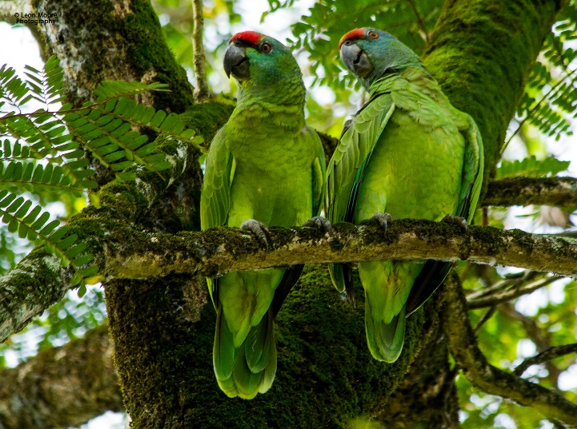**Day 2, Nov 11th. Georgetown and Surroundings:** This morning we will leave our hotel at 5:00am and head eastward along the Atlantic coast to the Mahaica River, this is where you will have your only chance on this tour of seeing and photographing Guyana’s national bird, the “Hoatzin”. This pre-historic bird is found in abundance along this river system along with many other species including Yellow-chinned Spinetail, Barred Antshrike, Black-crested Antshrike, Little Cuckoo and Striped Cuckoo, Green, Amazon, American pygmy and Ringed Kingfisher, Striated Heron, Black-collared Hawk, Black Hawk-Eagle and many other **(Festive Parrot)** amazing birds.

This area is also one of the best places to see and photograph the Guianan Red Howler Monkey so we will fancy our chances at capturing some great images of the stunning animal. The entire morning will be spent on the coast. After our time on the Mahaica river, on the way back to Georgetown we will stop at some mangrove forest at Victoria village seawall for a chance to see and photograph another of our target for the day, the Rufous Crab-Hawk! With reasonable luck, we hope to get some stunning pictures of this Guianan shield endemic species. Our journey will continue to Georgetown for a late lunch.

Later in the afternoon, we can revisit the Georgetown Botanical Garden to try and see if we can get pictures of the outrageous Toco Toucan or perhaps White-throated Toucan, Black-necked Aracari, Pied water-tyrant, Great-Horned Owl, Lineated and Crimson-crested Woodpecker. Not forgetting, this is a great place for several of the amazon parrots including the amazing Festive, Yellow-crowned, Orange-winged and the Mealy Parrot. We may also have lots of Red-shoulder Macaws to photograph as well.

Overnight at Grand Coastal Hotel (B ,L,D)

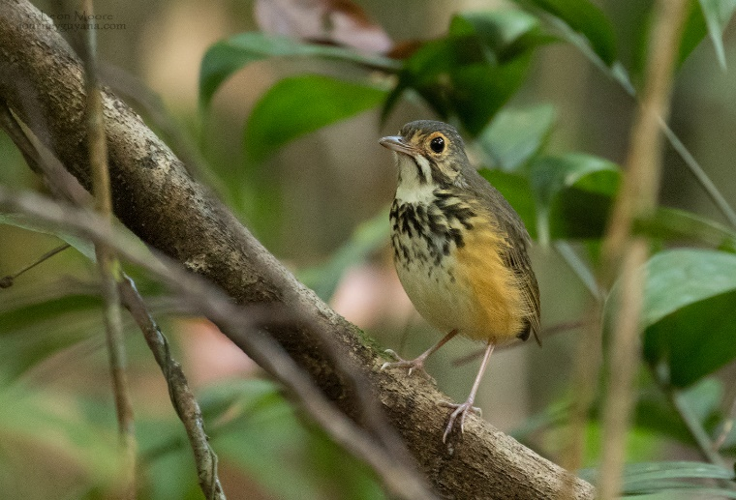**Day 3, Nov 12th . Georgetown to Iwokrama River:** After an early breakfast at our hotel, we will transfer to nearby Ogle Airport where we will catch a flight (by small aircraft) to the Amerindian village of Fairview. From here we will take a 10-minute transfer to Iwokrama River Lodge. The Iwokrama Rainforest, a vast wilderness of one million acres, is a protected area that was established in 1996 as the Iwokrama International Centre for Rainforest Conservation and Development. The Iwokrama Forest is in the heart of one of four last untouched tropical forests of the **(Spotted Antpitta)** world – The Guiana Shield of North-Eastern South America. Iwokrama was established as a living laboratory for tropical forest management because the unsustainable utilization of these forests will result in the extinction of half the world’s plant and animal species and unknown changes to global climate. This is a protected area with a difference – the full involvement of people. Iwokrama is exceptional among conservation organizations because it joins with local people in every aspect of its work. From research to business, Iwokrama ensures local economic and social benefits from forest use and conservation. The Forest is in the homeland of the Makushi people, who have lived here and used the forest for thousands of years. People are a vital part of the ecosystem, and the success of Iwokrama relies on the ownership of local people and the combined skills of specialists and communities. Iwokrama does what so many International conventions have acknowledged as best practice. It has begun conservation locally and integrated conservation into national development.

Upon our arrival at the river lodge, we will receive a welcome by the staff and then settle in to our rooms. The afternoon will be used to venture into the forest for an interpretive walk looking at the different trees, flowers and orchids. There is a Capuchinbird lek along one of the trails which we will be visiting, and you may also have chances to see several species of monkeys, including Red Howler, Black Spider, and Guianan Saki Monkey. We will return to the lodge at sunset. After dinner, we will venture out on the Essequibo River by boat in the dark with an expert boat captain looking for night animals including Tree Boas, Black Caiman, Ladder-tailed Nightjars, and, if the water is low enough, along the sandbanks you may have the chance to see some freshwater stingrays.

Overnight at Iwokrama River Lodge (B,L,D)

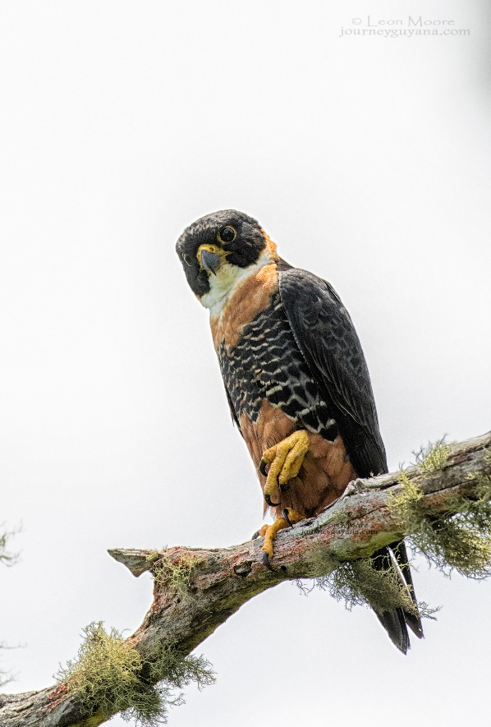**Day 4, Nov 13th . Iwokrama River Lodge and Environs:** We will start the day very early after breakfast. A trip to Iwokrama is not complete without a hike to the top of Turtle Mountain. We will take a boat journey downriver approximately 30 minutes and then enjoy a slow walk of about 1.5 hours up the forested trail to the summit (950 ft) for a stunning jungle vista punctuated by the powerful Essequibo River snaking through the forest. Numerous bird species can be spotted on the lower section of the trail including the Red-and-Black Grosbeak, Yellow-billed Jacamar, Brown-bellied Antwren, Ferruginous-backed Antbird, Guianan-Red Cotinga, Great Jacamar, Pygmy Antwren, Guianan Tyrannulet, Guianan Toucanet, Guianan Puffbird, Screaming Piha, Rufous-bellied Antwren, Collared Puffbird and many other birds.

We will make an extra effort to reach the top as it provides spectacular views of pristine rainforest along with many birds including one of our main targets for the day, the rare Orange-breasted Falcon! On previous trips our clients had amazing views of a pair **(Orange-breasted Falcon)** of Rufous-winged ground Cuckoo at the top of the mountain. Along with a possible sighting of the Falcon, this is another area we do not want to miss out on a chance to see the rare Ground Cuckoo. After returning the lodge, depending on the time, we will have the chance to explore the forest trails around the lodge looking for Rose-breasted Chat, Wing-banded Antbird, White-plumed Antbird, Rufous-throated Antbird, Brown-bellied and Rufous-bellied Antwrens. Spotted Antpitta, Yellow-throated and Waved Woodpeckers and a host of Woodcreeper; Chestnut-rumped, Red-billed, Amazonian-barred, Buff-throated, Lineated, and Wedge-billed. Before returning to the Lodge we will have another chance to visit the Capuchinbird lek.

Overnight at Iwokrama River Lodge (B,L,D)

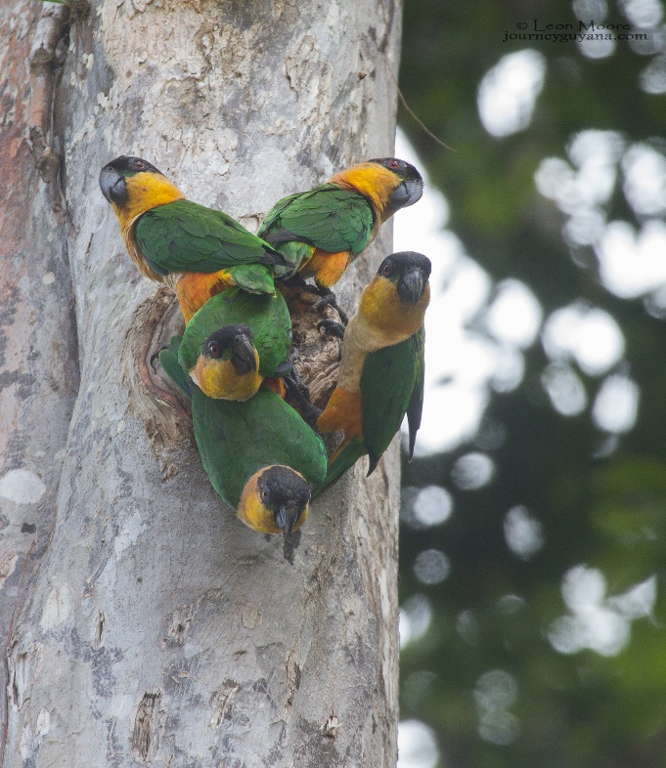**Day 5, Nov 14th . Transfer from Iwokrama to Atta Lodge and Canopy Walkway:** After an early breakfast, we will transfer to Atta Lodge and Canopy Walkway via Mori Scrub. Mori Scrub is a unique white sand forest about 40 minutes from the river lodge that hosts some key bird species such as Red-legged Tinamou, Red-shouldered Tanager, Bronzy Jacamar, Rufous-crowned Elaenia, Black Manakin, and Guianan Schiffornis, all intriguing birds that would be nice to add to your bird list. This area is very flat so the hike will be very easy. We will be sure to have our cameras and binoculars ready because occasionally Jaguars and other mammals are seen while driving through the rainforest. We cannot promise a big cat sighting but many have been lucky! We then continue to Atta Lodge where we will receive a welcome by the staff before settling in to our humble **Black-headed Parrot)** accommodation. The lodge is located within the 1,000,000 acres of protected rain forest of Iwokrama. After settling in, we will take an afternoon walk on the Canopy Walkway.

The lodge is situated approximately 750 meters from the Iwokrama Canopy Walkway. The walkway has three platforms, the highest of which is over 30 meters above the ground. These platforms and the walkway will allow us to get great looks at a range of canopy species. Among the likely highlights are Painted and Golden-winged Parakeets, Caica Parrot, Guianan Puffbird, Waved and Golden-collared Woodpeckers, and Spot-tailed, Todd’s and Ash-winged Antwrens. The walkway is also an excellent place to look for various species of Cotinga including the Dusky Purpletuft. If there are any suitable fruiting trees nearby, we stand a good chance of seeing this bird, as well as Purple-breasted Cotinga. Another area where we will spend some time is the clearing around the lodge, as this is one of the best places to see the Crimson Fruitcrow. This species is seen here on a regular basis, coming to feed in some of the nearby trees. The clearing is also a site for Black Curassow; a family party comes out to feed at the forest edge. With reasonable luck, we should be able to add this bird to the impressive list of species we hope to see around the lodge and walkway.

Overnight at Atta Lodge (B,L,D)

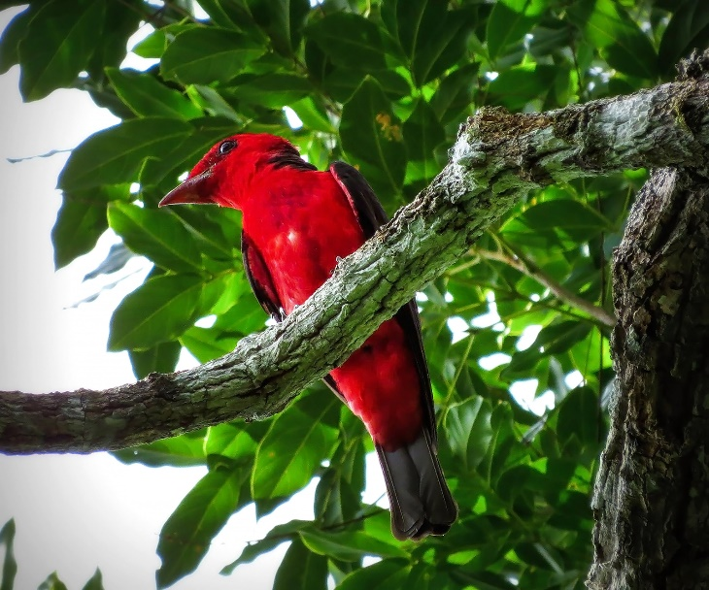**Day 6, Nov 15, Atta Rainforest Lodge and Environs:** This morning we will head out to the walkway at first light for opportunities to spot canopy species including Todd’s Antwren, Spot-tailed Antwren, Short-tailed Pygmy-Tyrant, Guianan Toucanet, Green Aracari, Painted Parakeet, Screaming Piha, Black-headed Parrot, Guianan Puffbird, Dusky Purpletuft, Great Jacamar, Paradise Tanager, Blue-backed Tanager, Golden-sided Euphonia, Purple and Green Honeycreepers, Black-faced Dacnis, Long-billed Gnatwren, Buff-cheeked Greenlet, Tiny Tyrant-Manakin and Black Nunbird. This entire morning will involve birding on the canopy walkway and **Crimson Fruitcrow)** the trails around the lodge.

Within the forest that surrounds the lodge we can look for Great and Variegated Tinamous, Spotted Antpitta, Red-and-Black Grosbeak, Grey-winged Trumpeter, Cayenne Jay, Amazonian Barred Woodcreeper, Red-billed Woodcreeper, Helmeted Pygmy-Tyrant, Painted Tody-Flycatcher, Ferruginous-backed Antbird, Guianan Warbling Antbird, White-crested Spadebill, and Waved, Chestnut and Red-necked Woodpeckers. We should spot Black Spider Monkey and White-faced Saki Monkey as we bird.

After lunch, we will spend the afternoon birding on the main road through the Iwokrama Forest. Blue-backed Tanager, Black-chinned, Scale-backed and Grey Antbirds, Guianan Streaked Antwren, Amazonian and Mouse-colored Antshrike, Reddish Hermit, Tiny Tyrant-Manakin, Rose-breasted Chat, Black and Red-throated Caracaras, Guianan Trogon, Golden-winged Parakeet and Yellow-green Grosbeaks are all possibilities. While birding along the road, we will also keep our eyes open for the elusive Jaguar and Tapir which are often seen at dawn and dusk. On our way back to Atta Lodge, we will use flashlights or spotlights to do some night birding, mainly looking for Owls and Potoos. This is a great place to look for Potoos, but it must be stressed these birds can be very hard to find. Nevertheless, there are possibilities for White-winged Potoo, Great Potoo, Common Potoo and Long-tailed Potoo, plus Northern Tawny-bellied Screech-Owl, Spectacled Owl, Black-banded Owl, Amazonian Pygmy-Owl and Crested Owl.

Overnight at Atta Rainforest Lodge (B,L,D)

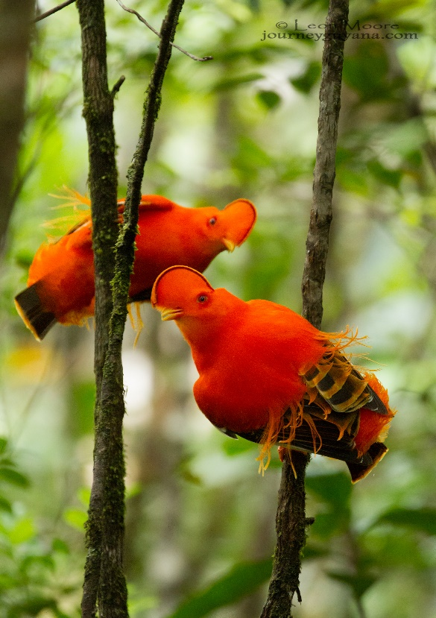**Day 7, Nov 16th. Atta Rainforest Lodge to Surama Lodge via Cock-of-the-Rock Lek:** Today we will rise before dawn, have some coffee, and then take our final morning at Atta Lodge birding the clearing around the Lodge to try for a few of our target species that we might have missed or to just get better looks at ones we’ve seen, including Green Aracari, Guianan Toucanet, Guianan Trogon, Painted Tody-Flycatcher, Guianan Tyrannulet and more. After our early morning birding and breakfast, we will venture onward to Surama Lodge with an important stop at a Guinean Cock-of-the-Rock lek, where this stunning bird is regularly seen as the males display for females. The lek’s location is about a 20-minute walk on a flat forest trail, and once there, we should have a good chance to see and photograph this unique bird. Some other species regularly seen along this trail include Yellow-billed Jacamar, Rufous-winged Ground Cuckoo, Spotted Antpitta, Amazonian Motmot, Scarlet and Red-and-green Macaws, Painted Parakeet, White-plumed **(Guianan Cock-of-the Rock)** and Rufous-throated Antbird, and more. We then continue to the Amerindian village of Surama, where you will be welcomed by the staff and then settle in to your basic accommodation for the next two nights.

The Amerindian community of Surama is located in the heart of Guyana. The village is set in five square miles of savannah which is ringed by the forest-covered Pakarima Mountains. Surama’s inhabitants are mainly made up of the Makushi people, one of the nine indigenous people of Guyana, and they still observe many of the traditional practices of their ancestors. After lunch, as the afternoon cools, we will have the option of touring the village or continuing to bird. Participants who opt for the latter will venture out into the savanna and through the forest for a chance to find White-naped Xenopsaris, Fiery-tailed Awlbill, Tufted Coquette and more. We may also visit a nearby pond to look for the Great Potoo that roosts in the area.

Overnight at Surama Lodge (B,L,D)

**Day 8, Nov 17th . Surama and Environs:** This morning we will rise before dawn for an expedition to see a very special bird, the incomparable Harpy Eagle. This, the largest eagle in the world, (although the Phillipine Eagle weighs more), is one of the most sought-after species among birders world-wide. We will drive a short distance through the forest in 4×4 vehicles to a trailhead. From there, the hike to the Harpy Eagle nest site is about an hour each way on flat terrain. We won’t know if the eagles are actively nesting until shortly before the trip, but we have a chance of seeing them in the area even if their nest is inactive when we visit.

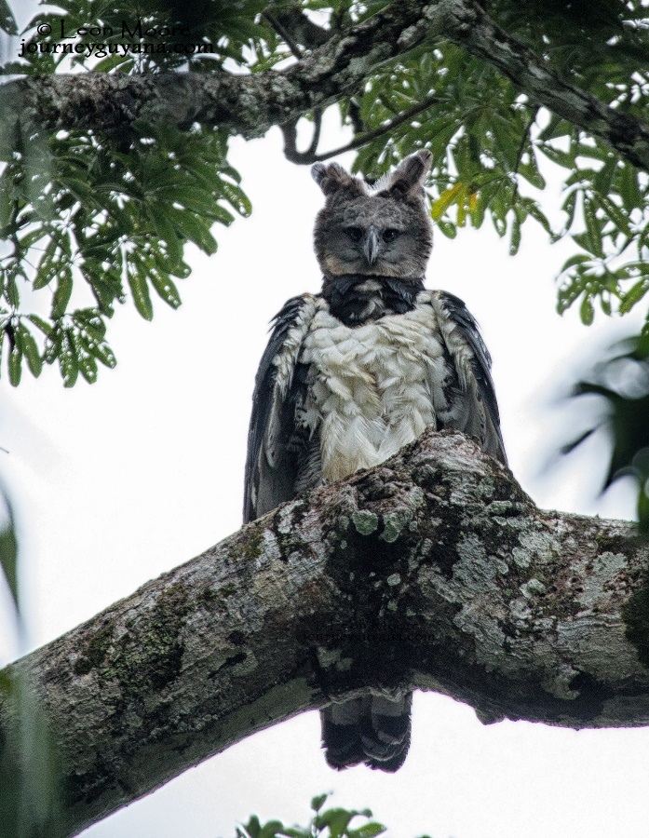The Harpy Eagle nests approximately every 2-3 years. The female sometime lays two eggs and takes nearly two months to incubate them. When the chicks hatch, the stronger of the two usually pushes the weaker from the nest; Harpy Eagles raise only one chick at a time. When a young chick is being fed, the male brings food to the female and young about once every 3.5 days. As the chick grows and both adults are hunting, they bring food to the nest about every 2.5 days. Typically, the fledgling eaglet is “branch-hopping” at the age of 4 – 6 months, and it will stay within 100 meters of the nest for more than a year after that, as the parents continue to provide its food. Even after the young eagle flies, the parents will continue to provide some food for another year or so and the birds will stay in the general vicinity of the nest.

**(Harpy Eagle)** Along the trail to the Harpy Eagle nesting area, as our naturalist guide teaches us interesting facts about the forest, we may see monkeys and a variety of other wonderful birds including the White-crested Spadebill, Brown-bellied Antwren, Rufous-bellied Antwren, Black-throated Antshrike, and Capuchinbird.

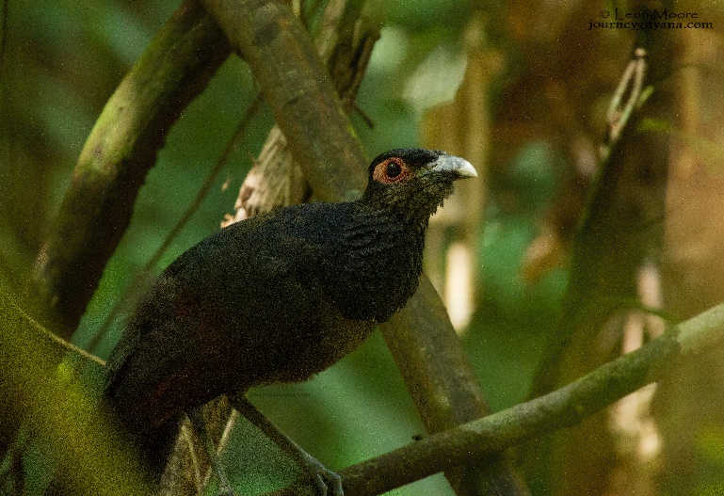We will be back at the lodge in time for lunch, and then, as the afternoon cools, we will take a walk or transfer across the savannah and through the rain forest to the Burro-Burro River. This river trail, is great for birding; some of the species that are likely to see includes the Rufous-capped Antthrush, Black-faced Antthrush, Capuchinbird, Fairy-tailed Awlbill, Red-legged Tinamou, Ferruginous-backed Antbird, Rufous-throated and White-plumed Antbird, Dusky Purpletuft, Guianan Toucanet, Guianan Red Cotinga and many other amazing birds.

Depending on your interest and what targets you want to see, our guides can also paddle us along the Burro-Burro River where we had good luck seeing Giant River **(Rufous-winged Ground Cuckoo)** Otters, along with several other species of birds including Green-and-Rufous Kingfisher, Guianan-streaked Antwren, White-banded Swallow, Green Ibis, Great Antshrike and Blue-throated Piping Guan. This depends on the level of the river!

During our stay at Surama Lodge, we also have a chance to target the very difficult Ocellated Crake. We will also try for Chapman’s Swift, Spotted Antpitta, Gray-winged Trumpeter, Tiny Tyrant-Manakin, Waved Woodpecker, Red-billed, Chestnut-Rumped and the Guianan Woodcreeper. We will remain alert in hopes of spotting the very elusive Rufous-winged Ground Cuckoo, and since our guides have found an area where this rare bird has been seen on several trips, optimism is justified. We will return to the village for sunset or return in the dark before dinner.

Overnight at Surama Lodge (B,L,D)

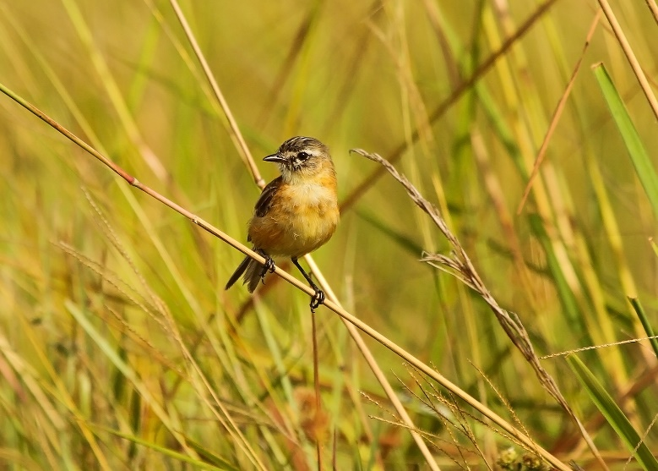**Day 9, Nov 18th . Transfer to Caiman House:** After another early breakfast, we will transfer to Caiman House with stops along the way to checking a few forest edges and many savannah ponds to see if we can locate birds like Grey-necked Wood-Rail, Cocoi Heron, Maguari Stork, Buff-necked Ibis, and the stunning Jabiru Stork. Raptors in the area include Savanna, Great Black and Zone-tailed Hawks. The morning’s journey ends at Caiman House where we will be welcomed by the staff, settle in to our accommodation, and then have lunch.

Caiman House Field Station was built in **(Bearded Tachuri)**  Yupukari by an American family who moved to the area so Peter Taylor could conduct a field study on Black Caiman (Melanosuchus niger), the largest member of the alligator family and a species that is listed by CITES as endangered. Black Caiman are severely depleted in nearly all of their former range, but are found in abundance in the waters of the Rupununi River. The field study is an attempt to gain an understanding of the Black Caiman’s ecological role, as well as its context within local communities. By basing the study in a local village, and using local residents as assistants, it will hopefully

instill a better understanding of the caiman’s importance in the local ecosystem. It is also hoped that a healthy population could lead to a sustainable resource, possibly through ecotourism. Guests are invited to join the caiman research crew in a night of caiman capturing. It’s a bit like having a job with a National Geographic crew.

Our afternoon will be spent patrolling the gallery forest surrounding Caiman House in search for more target species including Spotted Puffbird, Green-tailed Jacamar, Blue-backed Manakin, Black-crested Antshrike, Cream-colored Woodpecker, Golden-spangled Piculet, Northern Slaty-Antshrike, Slate-headed-Tody Flycatcher, Bare-necked Fruitcrow, Yellow-Olive Flycatcher, Pale-tipped Tyrannulet, Guianan-warbling Antbird, Southern-white frienged Antwren, Sooty-capped Hermit, Red-capped Cardainal, Yellow-crowned Parrot, Brown-throated Parakeet and many other amazing birds.

**Overnight at Caiman House (B,L,D)**

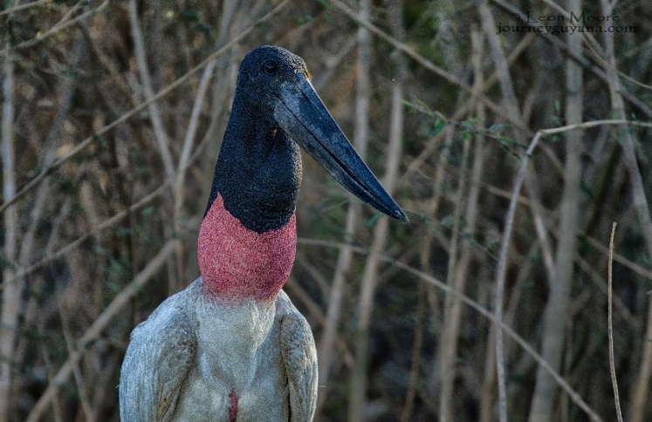**Day 4, Nov 19th . Caiman House and Environs:** After an early breakfast, we will have a chance to do some birding in the Savanna and forest patches that surrounds Caiman House. We will be mainly looking for serval seldom seen birds including the localized Crested Doradito, Bearded Tachuri, Jabiru Stork, Maguari Stork, White-face and Black-bellied whistling Duck, Pinnated Bittern, White-tailed Hawk, Savanna Hawk, Zone-tailed Hawk, White-tailed Kite, Aplomado Falcon and many other species.

**(Jabiru Stork)** We may also see Sharp-tailed Ibis, Yellowish Pipit, White-tailed Goldenthroat, Double-striped Thick-knee, King Vulture and Orange-backed Troupial. In addition, this will be the best time to see the very strange but yet still beautiful, the Giant Anteater! If we’re lucky enough to find one, we will enjoy the view and possibly take pictures. Eventually we will make our way back to Caiman House before lunch.

In the afternoon we will take boat trip on the Rupununi river for a chance of possibly seeing birds like the pale-legged Honero, American Pygmy, Green Kingfisher, Amazon and the Ringed Kingfisher. Meanwhile be on the lookout for birds like Capped Heron, Sungrebe, Sunbittern, Pied Lapwings, Black Skimmer, Large-billed Tern, Bare-necked Fruitcrow, Yellow-green Woodpecker Crestless Curassow, Hooded Tanager, Glittering-throated Emerald, White-lined Tanager, White-winged Swallow, Roaseate Spoonbill and the very shy Cressless Curassow. The river is home to both the Black and Spectacled Caiman. In addition, we sometimes see Gant River Otters and the occasional Arapaima, plus Amazon River turtles. As the sun sets over the river, we may see several Band-tailed Nightjars flying above and around us along with both Greater and Lesser bulldog bats as they get ready for the nightshift. We will return to boat landing and from there, a short hike back to the lodge. Along the way, we hope to see the Tropical Screech Owl, Common Potoo and the ferruginous Pygmy Owl before returning to the lodge for dinner.

Overnight at Caiman House (B,L,D)

**Day 11, Nov 20th . Caiman House to Karasabai**: This morning we will continue on our journey to Karasabai on rough road passing through very nice habitats such as open savanna and the Pakarima mountain range with gallery forest patches. Here Aplomado Falcon hunts over expansive plains with Grassland Yellow-Finches mixed with a variety of seedeaters, including Gray, Plumbeous, Chestnut, Ruddy and Lined Seedeaters. We also have good chances of encountering Giant Anteaters as they pass through the savanna. We will be passing lots of ponds, so these spots should produce very good birding opportunities for water birds such as herons, egrets and storks. We’ll need to keep an eye overhead as well for the raptors likely for this area: Savanna and White-tailed Hawks along with Lesser Yellow-headed and King Vultures. Many other great birds should 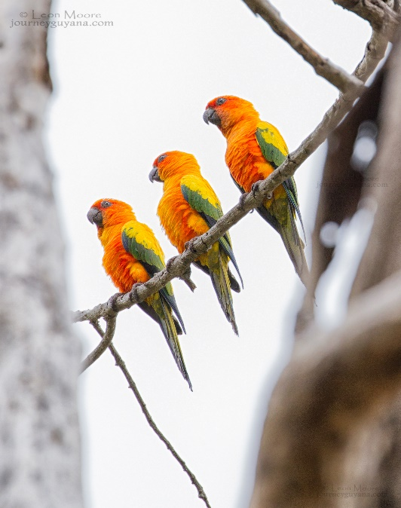be seen on the drive to this **(Sun Parakeet)** very remote village of Karasabai with its exceptionally friendly residents.

Upon arrival we will take time to visit some of the locals in order to secure official permission to bird the area. There are very few visitors here and we wish to ensure good relations and encourage ongoing conservation efforts, especially when considering that these people ultimately control the fate of the Sun Parakeet.

This riparian forest along the border of Brazil where we will be birding during the morning offers some very interesting birding opportunities. Our primary target species will be the Sun Parakeet, but we will also have chances to observe many other birds, including Red-and-Green Macaw, Green-rumped Parrotlet, Black-and-White Hawk-Eagle, Zone-tailed Hawk, Rufous-browed Peppershrike, and Ferruginous Pygmy-Owl, to name but a few.

Following lunch in the village, we will bird our way back to Manari Ranch, which is located just 15 minutes outside the town of Lethem near the Brazilian border. Upon arrival, we will meet our local guide who will be taking us to look for the very rare Rio Branco Antbird and the Hoary-throated Spinetail on our final morning in the Rupununi. We will settle in to our very simple but comfortable accommodation for the next two nights.

Overnight at Manari Ranch B,L,D

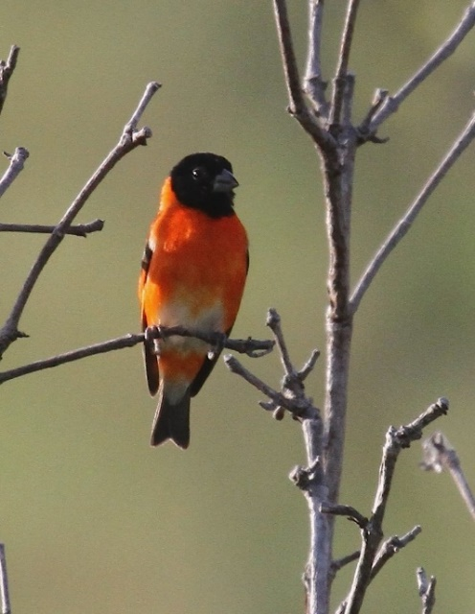**Day 12, Nov 21st . Manari Ranch to Dadanawa Ranch**: Today we have an extremely early start in search of the highly endangered Red Siskin South of Lethem. This requires traveling for several hours to Dadanawa Ranch. Upon arrival we will have breakfast before heading out in search of this unique bird. A fairly large population of Red Siskin was discovered in this region in 2003, far removed from any previously known colony, and we stand a good chance of observing this strikingly plumage species with an estimate world population of 600-6000 pairs. Our main objective will be to focus on locating the Siskin as this activity is just for one day at this stage of the tour and also due to the very long distance we have to cover in getting to and from the area, the sooner we can find them the better.

While our main focus will be on the Red Siskin they are **(Red Siskin)** other birds that we might come across including, Pale-bellied Tyrant- Manakin, White-barred Piculet, Bicolored Hawk, Savanna Hawk, and White-tailed Hawk, Zone-tailed Hawk, Flavescent Warbler, Ferruginous Pygmy-Owl, White-bellied Antbird, White-fringed Antwren, Crested Bobwhite, Rufous-winged Antwren and many more. We will return to Dadanawa Ranch for Lunch and then head back to our main Ranch for Dinner.

**Overnight at Manari Ranch (B,L,D)**

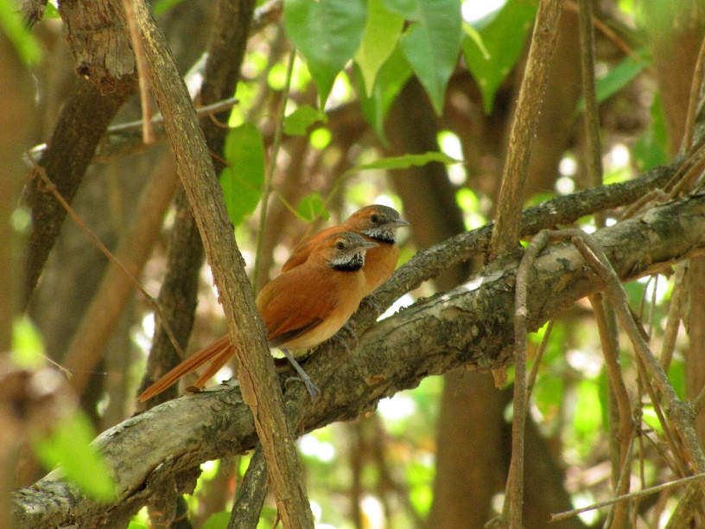**Day 13, Nov 22nd . Manari Ranch Surrounding and scheduled flight to Georgetown:** Today well focus our attention on two birds with exceedingly restricted ranges, the Hoary-throated Spinetail and the Rio Branco Antbird. Both species are only found in gallery forest along the Rio Branco River and other main tributaries, all of which ultimately flow into the Amazon. Recent agricultural pressures have seriously reduced the amount of available habitat for these birds, and as a result the Spinetail is now classified as endangered, with the Antbird treated as near-threaten. In **(Hoary-throated Spinetail)** order to reach suitable habitat for these we will travel by 4×4 through the open Savannah.

Along the way we might come access Maguari, Jabiru Storks, Black-Collared Hawk, Ring Kingfishers, and Rufous-tailed Jacamar, Black-chinned Antbird, Orange-backed Troupial and other species before reaching our site along a comparatively short stretch near the Iring River. We will specifically target the Hoary-throated Spinetail and the Bio Branco Antbird in this area, although other interesting species may include Pale-legged Hornero, Double-striped Thick-knee, Golden-spangle Piculet, and Ferruginous Pygmy-Owl, Flavescent Warbler and more.

After Lunch, will transfer you to Lethem Airstrip to connect with your schedule flight back to Georgetown. We will spend our final night in Guyana and celebrate your journey and experience of this beautiful Country.

**Overnight in Georgetown (B,L,D)**

**Day 14, Nov 23rd. Our final departure.** This morning we will transfer to the airport to connect with your international flight back home.

**Tour Cost:**

**Rates for Sun Parakeet Tour 2020**

**All rates are in US dollars showing cost as per person from 4 to 8 persons sharing in twin or double Rooms**

**Tour Size: A minimum of 4 tourists to go ahead and a maximum of 8 tourists**

|  |  |  |  |
| --- | --- | --- | --- |
| **Total number of Guest** | **4 Guest** | **6 Guest** | **8 Guest** |
| **Cost for clients** | **US$ 5,083** | **US$ 4,348** | **US$ 4,161** |
| **Added cost for Tour leader** | **US$ 2,932** | **US$ 2,619** | **US$ 2,415** |
| **Total cost for tour including tour leader** | **US$ 5,947** | **US$ 4,863** | **US$ 4,517** |

**Single Supplement is US$300 per person, subject to availability**

**Rates are subject to change due to currency fluctuation.**

**Please note: Tour prices are based on quoted costs from the lodges (in our local**

**FINANCIAL ARRANGEMENTS:**

**This includes:**

All meals as listed on the itinerary as Breakfast, Lunch and Dinner (B,L,D); from Lunch on day one to Dinner on your final evening in Georgetown Guyana; Day 13. Because our trips have to be planed way in advance and us not knowing your flight itinerary beforehand, we’ve decided not to include any meals on your departure (Day 14). This is to make sure we don’t over charge you for any meals due to, like for example; your flight is expected to leave Guyana at 4:00am. Breakfast will not be available at that time of day at your hotel.

**\*** All bottled drinking water.

**\***All lodging during the tour.

**\***Activities as mention in the itinerary above.

*All ground transportation and domestic flight in & out of the Rupununi. All ground transfer in between lodges, pick up and drop off at international Airport, all transfers for birding in Georgetown and transfers to Ogle Airport.

* All national park and other services entrance fees. Kaieteur national park fee, Iwokrama forest entrance fee, Surama village fee, Yupukari Village fee and Karasabai Village fee.

* All guiding services.

**This does not include:**

* Breakfast on Day 1. No meals included on your departure day; Day (14)

* Alcoholic Drinks

* Excess weight on the internal schedule flight

* Extra Activities

* Extra transfers

*Special gratuities, all phone calls and any other personal item of any nature.

* Tourist Visa

**Rates are subject to change due to currency fluctuation.**

**Please note: Tour prices are based on quoted costs from the lodges (in our local currency), estimated fuel costs, and the rate of exchange the time of itinerary publication. The erratic nature to global financial markets makes it difficult to predict changes in costs and foreign currency exchange rates over the long term. Since tours are priced well in advance of the actual operation of the tour, tour costs, fuel costs and exchange rates can change, sometimes drastically. Depending on the extent of such changes, it may be necessary to implement a surcharge on this tour. If a surcharge is necessary, every effort will be made to minimize the amount.**

**TERMS AND CONDITIONS**

**1. All requests for provisional or confirmed reservations are to be made by the Guest/Tour Operator by way of e-mail.**

**2. No reservation will be deemed confirmed unless acknowledged and accepted in writing by Leon Moore Nature Experience. Leon Moore Nature Experience will respond to all reservation applications in a timely manner and will reply using the same medium of communication whereby the request was made.**

**PAYMENT PROCEDURE**

**Payment Mode**

**3. You are required to make a non-refundable 20% deposit of the cost for the tour based on the number of clients and reservation made upon conformation of tour. And the balance no later than 90 days of the tour date.**

**All payment should be address to Leon Moore via wire transfer. Please advise** [**leonmoore40@yahoo.com**](mailto:leonmoore40@yahoo.com) **when deposit is made in writing.**

**CANCELLATIONS**

**Should any reservation or payment provision not be observed by the reserving party, Leon Moore Nature Experience will be entitled to cancel the respective reservation with immediate effect. This will be done by way of written notice.**

**CANCELLATION CONDITIONS**

**Should a cancellation be received between confirmation 50 and 40 days prior to arrival, no cancellation fee will be charged. Should a cancellation be received between 30 days prior to arrival a 50% cancellation fee will be charged. Should a cancellation be received 7 or less days prior to arrival no refund will be given. Cancellation fees are calculated on the rate per person and on the total value of the trip. No refunds will be made for unused meals, accommodations, or other trip features.  All reservation amendments or cancellations are valid only if advised and accepted in writing. Leon Moore Nature Experience strongly recommend that guests consider a travel insurance policy, which may assist in offsetting any unforeseen cancellation charges.  You may have the opportunity to transfer your booking to another tour or another person, provided you are unavoidably prevented from coming on the tour. In this case, you will bear any extra costs that such changes may incur.**

**INTERNATIONAL FLIGHTS**

**The cost of this tour does not include the price of your international flight to and from Guyana. You are responsible for arranging these flights to and from Georgetown. I recommend that you arrive a day early to rest and adjust to the time zone.**

**TRIP INSURANCE**

**The purchase of trip cancellation insurance is strongly recommended. Leon Moore Nature Experience (LMNE) cannot accept liability for airline cancellations or delays or penalties incurred by the purchase of nonrefundable airline tickets or other expenses incurred by tour participants in preparing for this tour.**

**On domestic Schedule flights within Guyana, passengers are allowed a total of 20Lbs or 9kg of luggage on Aircraft; if one is over the limit, he or she is charged US$1 or GY$ 200 Guyana dollars for every pound over weight. It is important that clients must provide his or her body and luggage weight in advance so this can be provided to the domestic airline in Guyana.**

**Because most of our clients comes from either north America or the UK; we know that clients would sometimes have to travel with weather clothing/extra jacket for cold weather; these and any other clothing or items he or she wish to leave within our storage, arrangements can be made to facilitate this.**

**\*Tipping:** The cost does not include any tips however, it is totally up to you, if you feel that an individual/staff performed excellent and you wish to leave a tip please do. If you feel that your tour leader provided you with excellent service, you are free to tip him as well.

* **Please Note:** Guyana is generally hot and humid. We can expect all types of weather from warm and hot to cool and rainy at times. Please be prepared for this.
* On most morning we will be up and out very early to take advantage of the cooler temperature and wildlife activity.
* This tour does not require a high level of fitness but participants should be in good general health as some of the birding will be done on foot and may require walking for several hours at times but at (slow pace). Should you have any physical limitation please let us know in advance before you leave your destination.
* Accommodation is generally simple but comfortable, throughout they are no air-conditioners at the interior lodges, you should not expect luxury accommodation, the lodges we use range from basic to very good, Caiman House Field Station, Surama, Atta, and Iwokrama to name a few!
* Apart from your hotel in Georgetown, none of the interior Lodges have hot shower.
* Some interior local roads can be bumpy at times based on condition.
* The vehicle we used are generally 4x4 and sometime open tops so at times we can be either sitting or standing to get a better view of possible wildlife or the forest.
* None of the Interior Lodges accept Credit cards, on arrival you can change and get money from a Bank, Cambio etc.
* Mosquito nets are provided throughout the lodges, you can expect some biting insects like mosquitos, sandflies, (noseeams).
* The risk of catching Malaria is low.
* Electricity is available at all the lodges, Generator or Solar power. Although the lodges are 110V and the outlets/plugs are USA type.
* **Immigration:** Please treat immigration checks as international standards e.g. no liquid, bug spray, cream etc. etc.
* **Clothing & footwear:** Light material clothing that can dry quickly, long sleeve, shirt and trousers for trail walks and tour activities. No brightly colored clothing, you must bring clothing that blends with the forest. Ankle height hiking boots and sneakers, with socks.
* **Trail Walks**: For extended period of tour activities, we recommend that you bring a 3 legged stool for you to sit on. Some tour excursions include standing for long hours. You will find having a 3 legged stool would come in handy. So please try your best to bring one with you.
* Thank you for traveling with Leon Moore Experience, Birding, wildlife  Spotting and Photography trips at  [journeyguyana.com](http://www.journeyguyana.com)

Find us one Facebook at  <https://www.facebook.com/JourneyGuyana/>

**Address:** Lot 485, Ornoque Drive, Mackenzie, Linden, Guyana, South America

Contact us: [leon@journeyguyana.com](mailto:leon@journeyguyana.com) or [leonmoore40@yahoo.com](mailto:leonmoore40@yahoo.com)

Tel: +1 (592) 655-9548 or +1(592) 444-21-67

.